CA 2

Nhóm 13

**Data: contact-lenses**

Attribute: 5

Instances: 24

Sum of weight: 24

**Attribute: age**

Type (loại dữ liệu): Nominal

Missing (dữ liệu thiếu): 0 (0%)

Distinct: 3

Unique (dữ liệu duy nhất): 0 (0%)

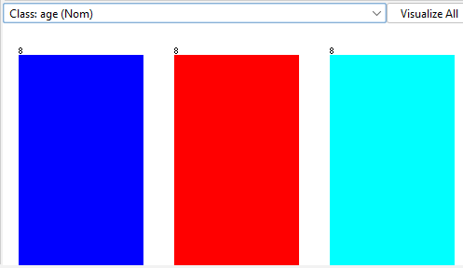

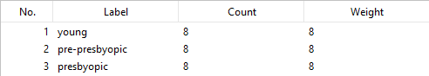

**Attribute: spectacle-prescrip**

Type: Nominal

Missing: 0 (0%)

Distinct: 2

Unique: 0 (0%)

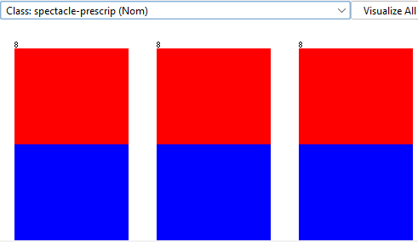

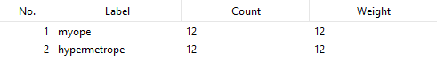

**Attribute: astigmatism**

Type: Nominal

Missing: 0 (0%)

Distinct: 2

Unique: 0 (0%)

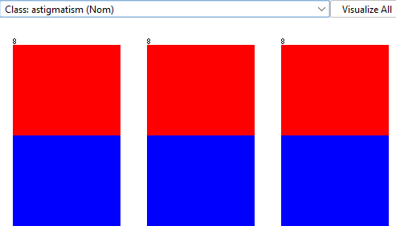

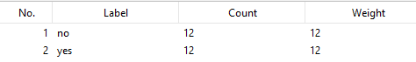

**Attribute: tear-prod-rate**

Type: Nominal

Missing: 0 (0%)

Distinct: 2

Unique: 0 (0%)

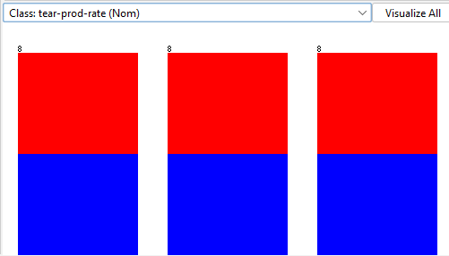

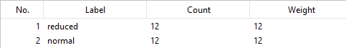

**Attribute: contact-lenses**

Type: Nominal

Missing: 0 (0%)

Distinct: 3

Unique: 0 (0%)

